Item Transfer Custom Report Error
- First go to Item Transfer Module, select any already created transfer document
- Click on Reports in the top left and try creating the custom report called TransferSlip as can be seen in the screenshot below
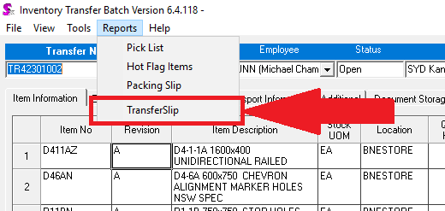
3)The following error would then pop up
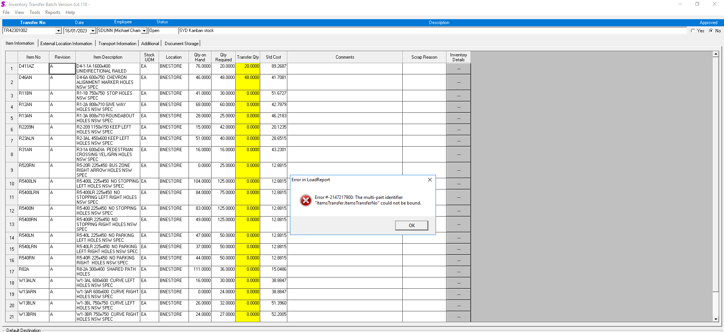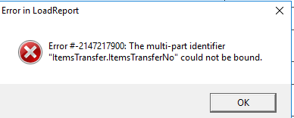
4)The error # here does not make sense so not sure as to where or what this error message refers to.

I can confirm that the crystal report itself seems to be printing amicably in print preview:
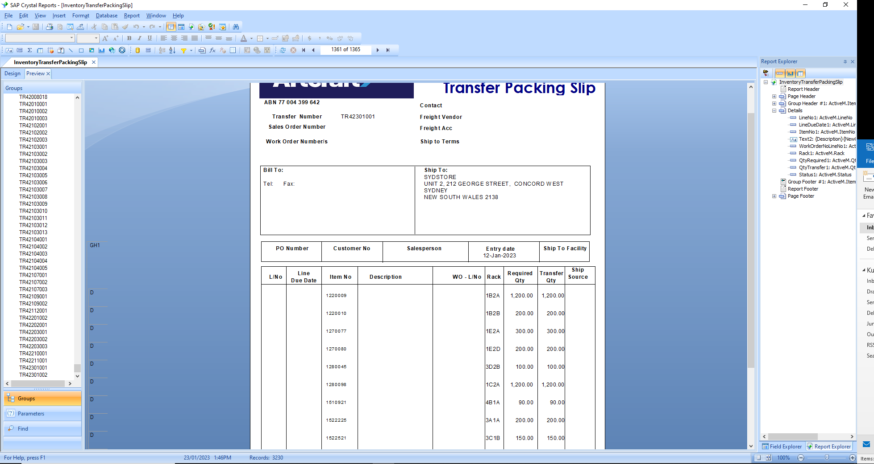
I can also confirm the relevant views that this report depends on are working:
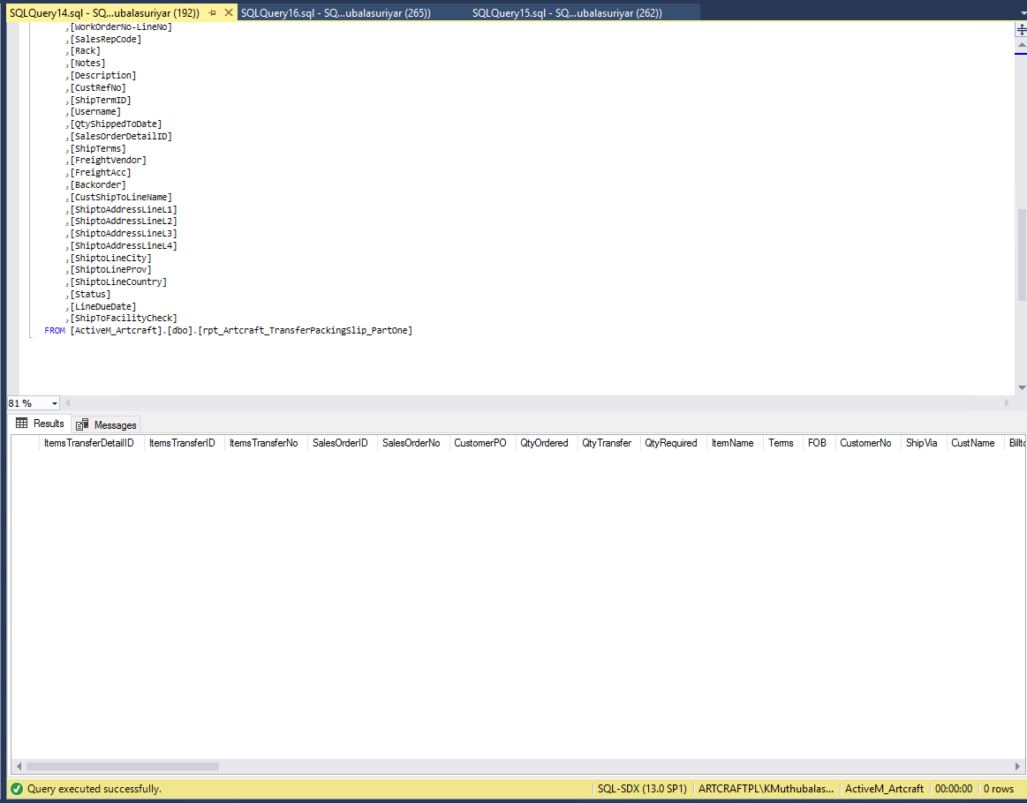
The above view, rpt_Artcraft_TransferPackingSlip_PartOne , shows all transfers that are linked to sales orders which at this point there are none, but execute correctly
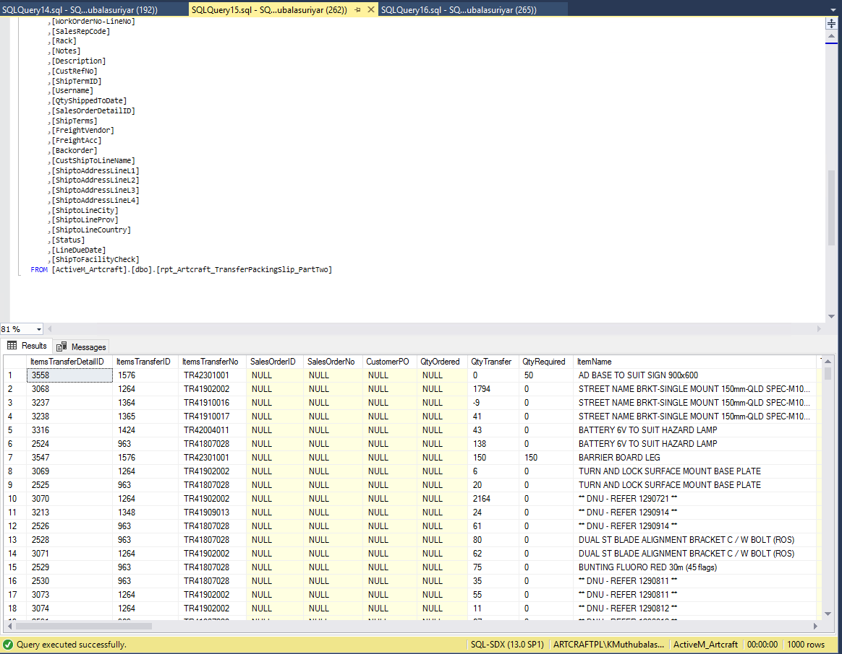
The above view, rpt_Artcraft_TransferPackingSlip_PartTwo, shows the Transfers not linked to a sales order of which there are 3269.
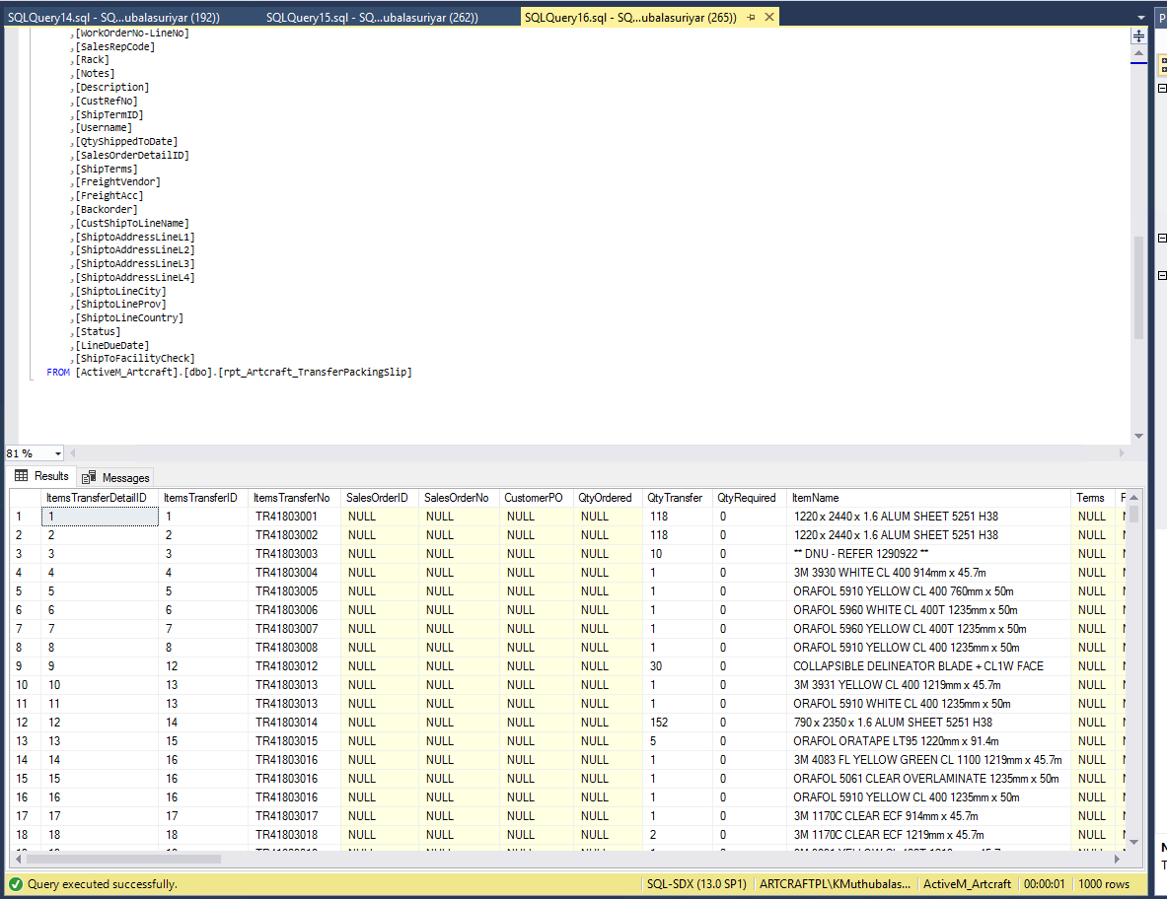
Finally this view, rpt_Artcraft_TransferPackingSlip, combines the previous 2 views through a union to pass onto the report. The report uses this view as its datasource.

I have checked on the crystal report on whether the database is up to date:
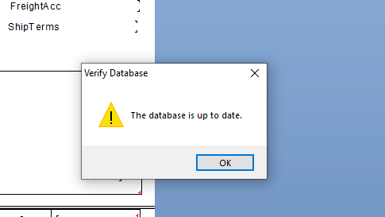
And every time I made a change to the report, I would save and reset the datasource location to update it properly as refreshing sometimes is not enough:
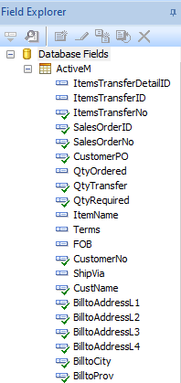

Given all this, I am under the impression that there is an error with the clients.mdb file or the connection between seradex and crystal reports in the itemsTransfer module. This seems likely as the error # overflow would’ve been triggered by this error.

